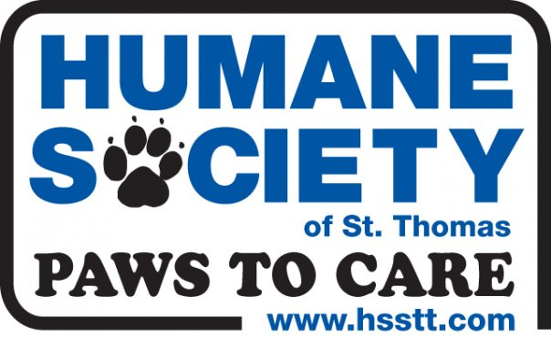

**Hours of Operation:**

**Mon, Tues, Wed, Fri & Sat**

11 A.M. – 5 P.M.

**Sunday:** 11 A.M. - 3 P.M.

**Thursday:** Closed to the public

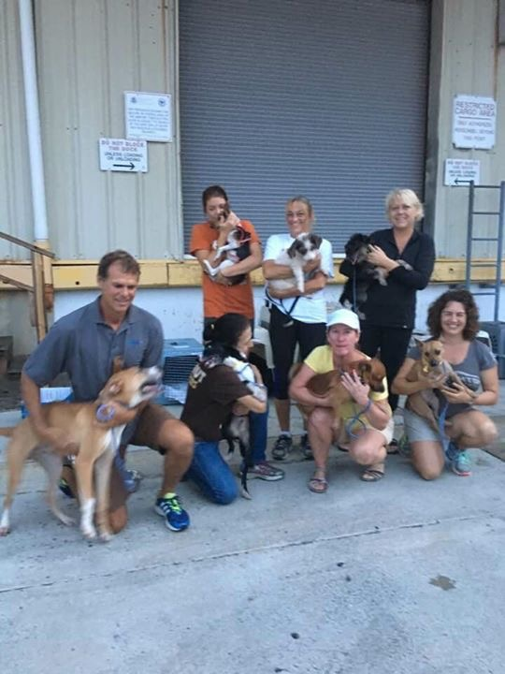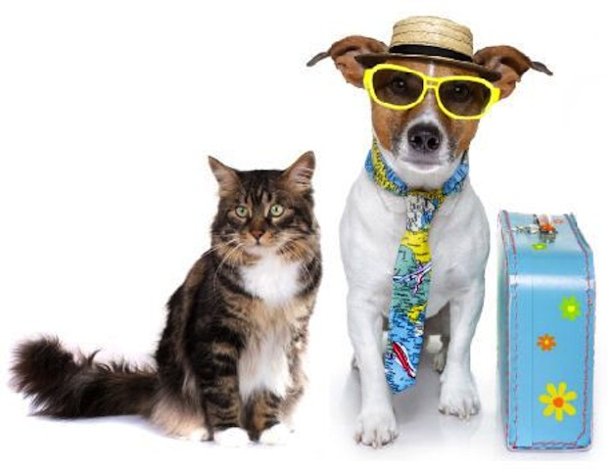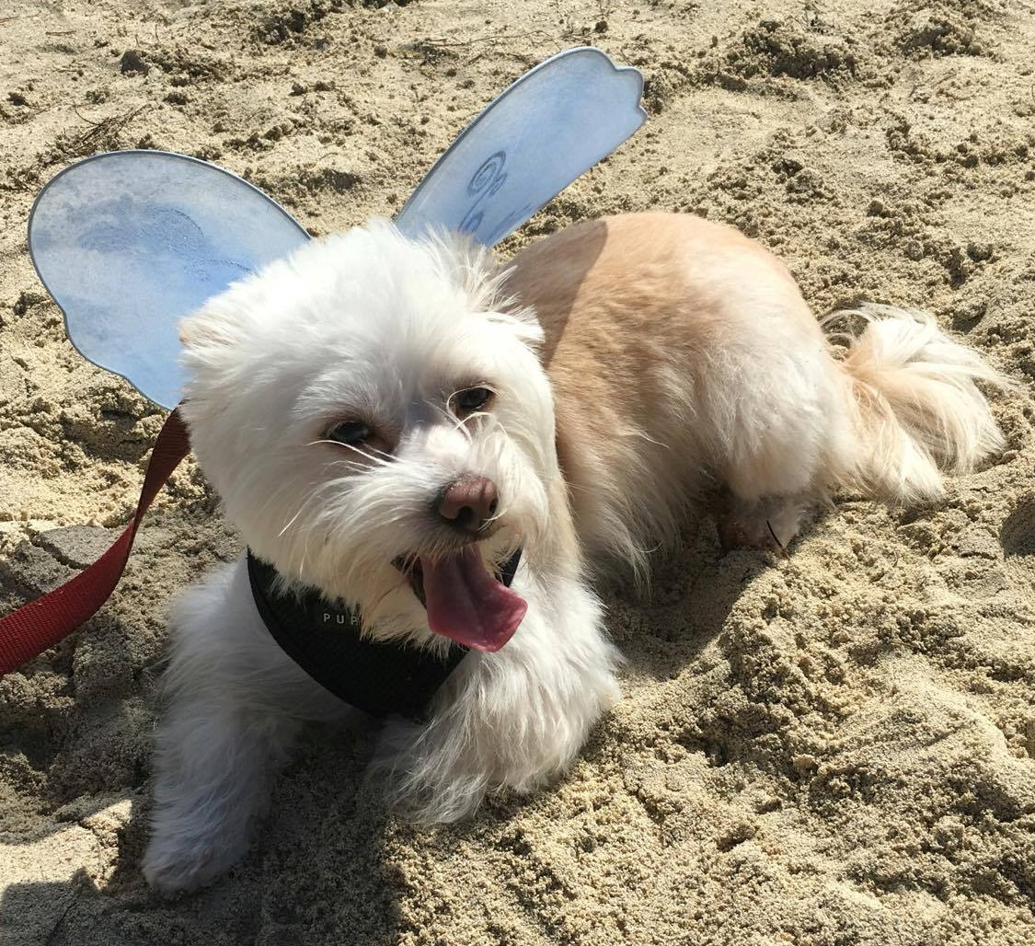

Pets with Wings   
4012 Rhymer Highway   
St. Thomas, US Virgin Islands 00802

(340) 643-0796 0r 340-690-0215

Follow PWW on Facebook

operationsaveapuppy @yaho.com

### Volunteer as a pet escort and save a life by transporting an island pet to a stateside rescue or home.

**Thank you** for your interest in volunteering!

Pets with Wings appreciates every little bit of help. Through the help of volunteers, Pets with Wings is able to save lives, four paws at a time.

**Pets with Wings Program**

## Image result for humane society volunteer

## 

How to save a life

Transport:

* Volunteers needed for travel with pets back to the following states:
  + Massachusetts,
  + New York
  + Connecticut
  + Illinois
  + Colorado
  + Pennsylvania
  + Missouri
  + Michigan
  + Florida
* If your destination is not listed, please call us at 340.463-0796 or 340-690-0215 or email us at [operationsaveapuppy@yahoo.com](mailto:operationsaveapuppy@yahoo.com) as we add new locations frequently.
* A volunteer from the rescue or shelter will meet you upon at the STT airport and at your destination.

Donate:

* Funds are needed for vaccines, health certificates to fly and transportation.
* Transporting one animal can cost between $100 and $200 depending on the airline.

# Pets with Wings is a program under the Humane Society of St. Thomas which is a Non-Profit Organization

**HOW THE PROGRAM WORKS:**

All animals accepted to be transported are evaluated for health and temperament. When a traveler is identified, contact is made with the stateside rescue in that area to identify the animal (dog or cat) that is suitable for that partner rescue. The animals are then transported stateside either in cargo or in cabin with a ticketed passenger. Any one traveling to one of our partner cities – can accompany an animal there as a “flight volunteer.”

And the process is s entirely stress-free. Pets with Wings volunteers complete the necessary paperwork and make the payments to the airlines. They meet the “flight volunteer” at the check-in counter at the airport with the animal. The passenger accompanies the animal through customs and immigration and is given a pet travel kit with necessary information and supplies for the pet. At the end of the flight, a representative from our rescue partner will meet the flight volunteer to take hold of the pet.

There is seldom a dry eye at this moment of parting, but each “flight volunteer” leaves with a full heart, knowing another innocent is destined for a loving home and a promising future.

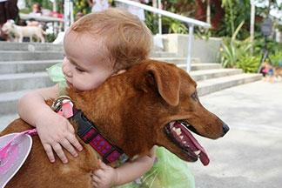



Pets with Wings’ Goal:

To transport as many animals as possible from the Humane Society of STT to rescue groups and shelters on the U.S. mainland where there are shortages of adoptable pets.

About the Program:

Pets with Wings was started by Leslie Hurd and Rhea Vasconcellos in 2012 when they saw a need to provide new lives and good homes for some of the island’s neediest animals Although many find wonderful homes here, there not enough homes for them all.

